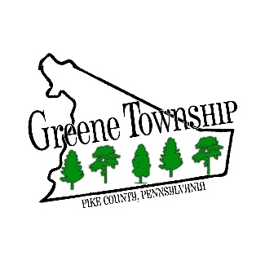
198 Brink Hill Road ٠ Greentown, PA 18426
(570) 676-9325 ٠ www.greenetownship.org

REGULAR MEETING AGENDA
SEPTEMBER 7, 2022

- Call to Order and Pledge of Allegiance
- Adopt Agenda
- Action on Minutes
  - Regular Meeting – August 3, 2022
  - Special Meeting – August 15, 2022
- Announcement of Meetings
- Recognition of Visitors
- Solicitor
- Road Report
- SEO Report
- Code Enforcement Report
- Unfinished Business
  - Short-Term Rental Ordinance
  - Noise Ordinance
- New Business

- Adjournment

