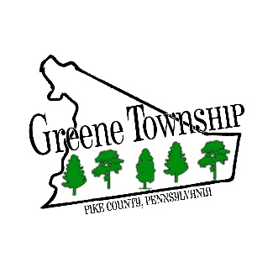
198 Brink Hill Road ٠ Greentown, PA 18426
(570) 676-9325 ٠ www.greenetownship.org

REGULAR MEETING AGENDA
NOVEMBER 2, 2022

- Call to Order and Pledge of Allegiance
- Adopt Agenda
- Action on Minutes
  - Regular Meeting – October 5, 2022
  - Special Meeting – Workshop for 2023 Budget – October 20, 2022
- Announcement of Meetings
- Recognition of Visitors
- Solicitor
- Road Report
- SEO Report
- Code Enforcement Report
- Unfinished Business
  - Adopt Short-Term Rental Ordinance
- New Business
  - Resolution 22-11 – Implement Act 57 for Tax Penalty Waiver
  - Resolution 22-12 – Pike County Hazard Mitigation Plan
  - Woods Lot Combination
  - Distribution of Foreign Fire Insurance
- Adjournment

